**Summer Internship Report**

Neural Network and Deep Learning

**Submitted By:**

Rohan Sharma

18CSU178

# **CERTIFICATE**

We hereby declare that the work being presented in major project report entitled **“Deep Learning and Neural Network”** towards the partial fulfillment of the requirement for the award of degree of **Bachelor of Technology** in **CSE & IT** is an authentic record of our own work.

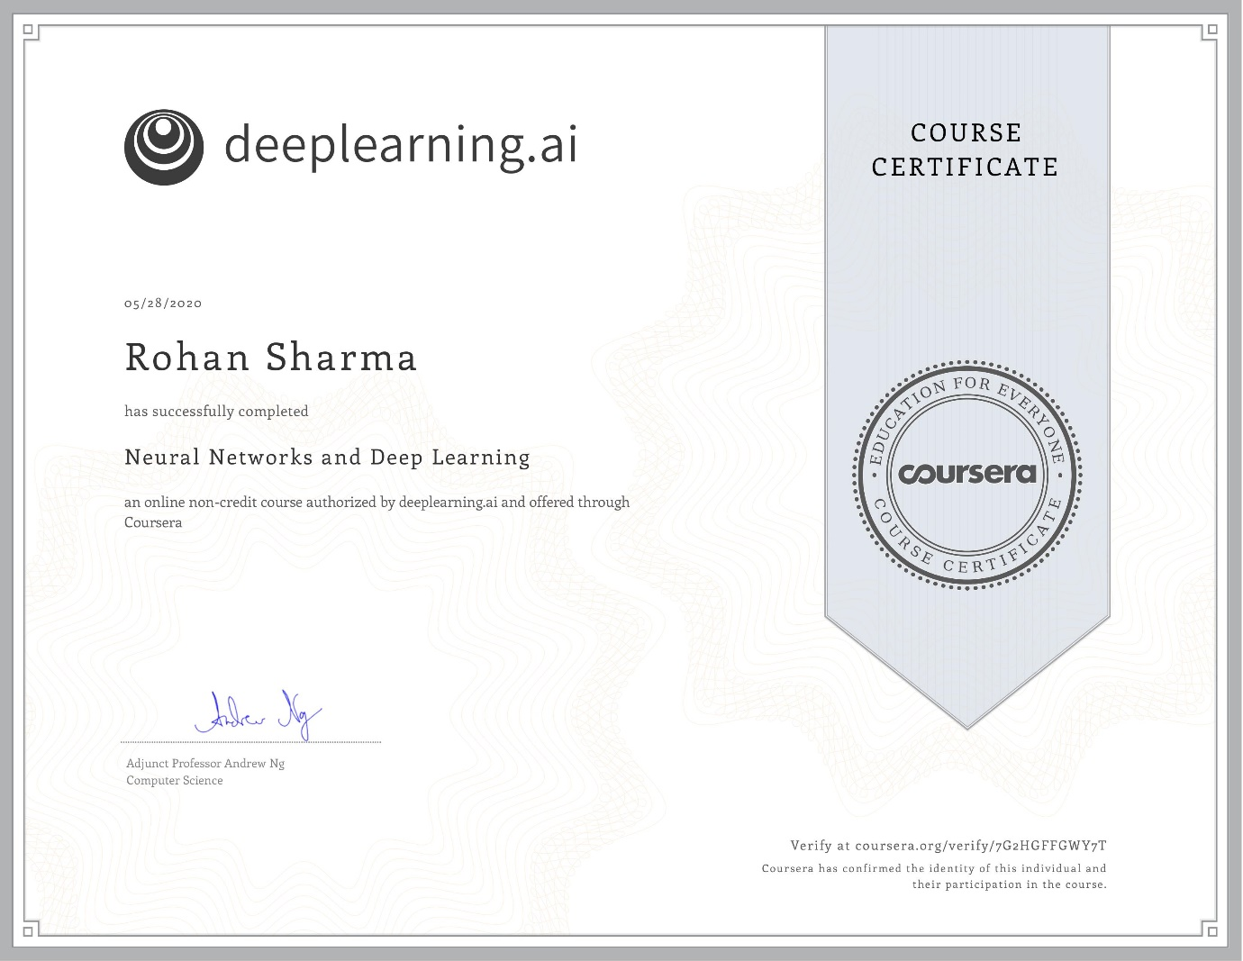

**ACKNOWLEDGEMENT**

On May 28, 2020 , I completed the ‘**Neural Networks and Deep Learning**’ course offered by [**deeplearning.ai**](http://deeplearning.ai/)on [**coursera.org**](http://coursera.org/). I would like to show my gratitude to Andrew Ng, Course Instructor, for teaching the course. I appreciate his intuitive teaching and explaining practical applications of neural networks. I would also like to express my gratitude to college faculty for providing opportunity to do this course.

Rohan Sharma:18csu178

**ABSTRACT**

Neural networks are a set of algorithms, modeled loosely after the human brain, that are designed to recognize patterns. They interpret sensory data through a kind of machine perception, labeling or clustering raw input. The patterns they recognize are numerical, contained in vectors, into which all real-world data, be it images, sound, text or time series, must be translated. **Deep**-**learning networks** are distinguished from the more commonplace single-hidden-layer **neural networks** by their depth; that is, the number of node layers through which data must pass in a multistep process of pattern recognition. ... More than three layers (including input and output) qualifies as “**deep**” **learning**. Neural networks help us cluster and classify.

There are many different goals of AI with different techniques used for each. The primary topics of this project are neural networks and an advanced version known as deep learning.

**INDEX**

Certificate………………………………………………………………………. 2

Acknowledgement…………………………………………………………….... 3

Abstract…………………………………………………………………………. 4

Introduction………………………………………………………………………6

Training Objective …………..……………………………………………..…….7

About the course…………………………………………………………….........8

Instructor………………………………………………………………….............9

Course Syllabus………………………………………………………...................10

Week 1 learning outcome (Programming assignment) ………..………………….12

Week 2 learning outcome (Programming assignment) ……………………………13

Week 3 learning outcome (Programming assignment) …………………………….16

Week 4 learning outcome (Programming assignment) …………………………….19

Outcome on new Dataset……….……………………………………………............21

Conclusion………………………….………………………………………………25

Reference….……………………………....……………………………………….26

Project Daily Task…………………………………………………………………27

**INTRODUCTION**

Deep learning (also known as deep structured learning) is part of a broader family of machine learning methods based on artificial neural networks with representation learning. Learning can be supervised, semi-supervised or unsupervised. Deep learning architectures such as [deep neural networks](https://en.wikipedia.org/wiki/Deep_learning#Deep_neural_networks), [deep belief networks](https://en.wikipedia.org/wiki/Deep_belief_network), [recurrent neural networks](https://en.wikipedia.org/wiki/Recurrent_neural_networks) and [convolutional neural networks](https://en.wikipedia.org/wiki/Convolutional_neural_networks) have been applied to fields including [computer vision](https://en.wikipedia.org/wiki/Computer_vision), [machine vision](https://en.wikipedia.org/wiki/Machine_vision), [speech recognition](https://en.wikipedia.org/wiki/Automatic_speech_recognition), [natural language processing](https://en.wikipedia.org/wiki/Natural_language_processing), [audio recognition](https://en.wikipedia.org/wiki/Audio_recognition), social network filtering, [machine translation](https://en.wikipedia.org/wiki/Machine_translation), [bioinformatics](https://en.wikipedia.org/wiki/Bioinformatics), [drug design](https://en.wikipedia.org/wiki/Drug_design), medical image analysis, material inspection and [board game](https://en.wikipedia.org/wiki/Board_game) programs, where they have produced results comparable to and in some cases surpassing human expert performance.

Deep learning allows machines to solve relatively complex problems even when using data that is diverse, less structured or interdependent. Deep learning is a form of machine learning that is inspired and modelled on how the human brain works. In this course we are introduced to the basics of deep learning and have learn how it compares to other techniques. During the course we have also understand the applications of deep learning in various fields and learn more about different frameworks used for neural networks.

**TRAINING OBJECTIVE**

Neural Networks and Deep Learning is the first course in the Deep Learning Specialization. The courses spans for 4 weeks and covers all the foundations of Deep Learning. Each week has at least one quiz and one assignment. The quizzes have multiple choice questions, and the assignments are in Python and are submitted through Jupyter notebooks.

Our objective to take this course is to learn and explore different functions, features in Deep learning and neural network. Also to make and work on a working project using deep learning and neural network. For this we created logistic regression model i.e. single layer neural network model and hidden layer neural network model.

**ABOUT THE COURSE**

Deep learning is an AI function that mimics the workings of the human brain in processing data for use in detecting objects, recognizing speech, translating languages, and making decisions. Deep learning AI is able to learn without human supervision, drawing from data that is both unstructured and unlabelled. To improve the performance of a Deep Learning model the goal is to the reduce the optimization function which could be divided based on the classification and the regression problems.

In this course, we have learn how to build a new network including a deep neural network and how to train it on data. There is a cat neem running around in deep learning. And so, we'll build a cat recognizer.

In the second week, we have learned about the Basics of Neural Network Programming. Then we have learned the structure of what we call the forward propagation and the back propagation steps of the algorithm and how to implement neural networks efficiently.

In third week we have learned the framework for neural network programming, we code up a single hidden layer neural network. In order to learn all the key concepts needed to implement and get to work in neural network.

Then finally in fourth week, we build a deep neural network and neural network with many layers and see it working.

**INSTRUCTOR**

**Andrew Ng** is VP & Chief Scientist of Baidu; Co-Chairman and Co-Founder of Coursera; and an Adjunct Professor at Stanford University.

Ng is an [adjunct professor](https://en.wikipedia.org/wiki/Adjunct_professor) at [Stanford University](https://en.wikipedia.org/wiki/Stanford_University) (formerly associate professor and Director of its [AI Lab](https://en.wikipedia.org/wiki/Stanford_AI_Lab)). Also a pioneer in [online education](https://en.wikipedia.org/wiki/Online_education), Ng co-founded [Coursera](https://en.wikipedia.org/wiki/Coursera) and deeplearning.ai. He has successfully spearheaded many efforts to "democratize deep learning" teaching over 2.5 million students through his online courses. He is one of the world's most famous and influential computer scientists being named one of Time magazine's 100 Most Influential People in 2012, and Fast Company's Most Creative People in 2014. Since 2018 he launched and currently heads AI Fund, initially a $175-million investment fund for backing artificial intelligence start-ups.

**COURSE SYLLABUS**

The course spans over 4 weeks starting with the basics and building upon it each week. It starts with the simplest 1-Layer neural network in the second week and complete an L-Layer neural network in the fourth week.

#### Week 1 – Introduction to deep learning

In the first week, introductions about Neural Network and Deep Learning are discussed.

* Introduction to Neural Network
* Supervised learning with Neural Network
* Reasons for Deep Learning taking off

#### Week 2 – Neural Networks Basics

The second week is, in my opinion, the foundation week for the specialization. Many of the important concepts of Deep Learning are discussed. There are also refreshers on calculus and linear algebra.

* Derivatives
* Binary Classification
* Logistic Regression
* Cost Function
* Gradient Descent
* Computation graph and Derivatives with a Computation Graph
* Vectorization and Vectorising Logistic Regression/Gradient Output

#### Week 3 – Shallow neural networks

The lectures from third week teach how to build a neural network with one hidden layer using forward propagation and back propagation.

* Two-layer Neural Network
* Neural Network Representation
* Computing a Neural Network’s Output
* Vectorising across multiple examples
* Activation functions, need for non-linear activation functions and derivatives of activation functions
* Gradient descent for Neural Networks
* Random Initialization

#### Week 4 – Deep Neural Networks

In the last week, we learn about the key computations underlying deep learning, and use them to build and train deep neural networks, and apply it to computer vision

* Deep L-layer neural network
* Forward Propagation in a Deep Network
* Matrix dimensions’ right
* Purpose of Deep representations
* Building blocks of deep neural networks
* Forward and Backward Propagation
* Parameters vs Hyper parameters

**Week 1 learning outcomes (Programming assignment)**

**Key Points: -**

* Understand the major trends driving the rise of deep learning.
* Be able to explain how deep learning is applied to supervised learning.
* Understand what are the major categories of models (such as CNNs and RNNs), and when they should be applied.
* Be able to recognize the basics of when deep learning will (or will not) work well.

**Quiz Outcome**



**Week 2 learning outcomes (Programming assignment)**

**Key Points:-**

* Build a logistic regression model, structured as a shallow neural network
* Implement the main steps of an ML algorithm, including making predictions, derivative computation, and gradient descent.
* Implement computationally efficient, highly vectorized, versions of models.
* Understand how to compute derivatives for logistic regression, using a backpropagation mindset.
* Become familiar with Python and Numpy
* Work with iPython Notebooks
* Be able to implement vectorization across multiple training examples

**Quiz Outcome**

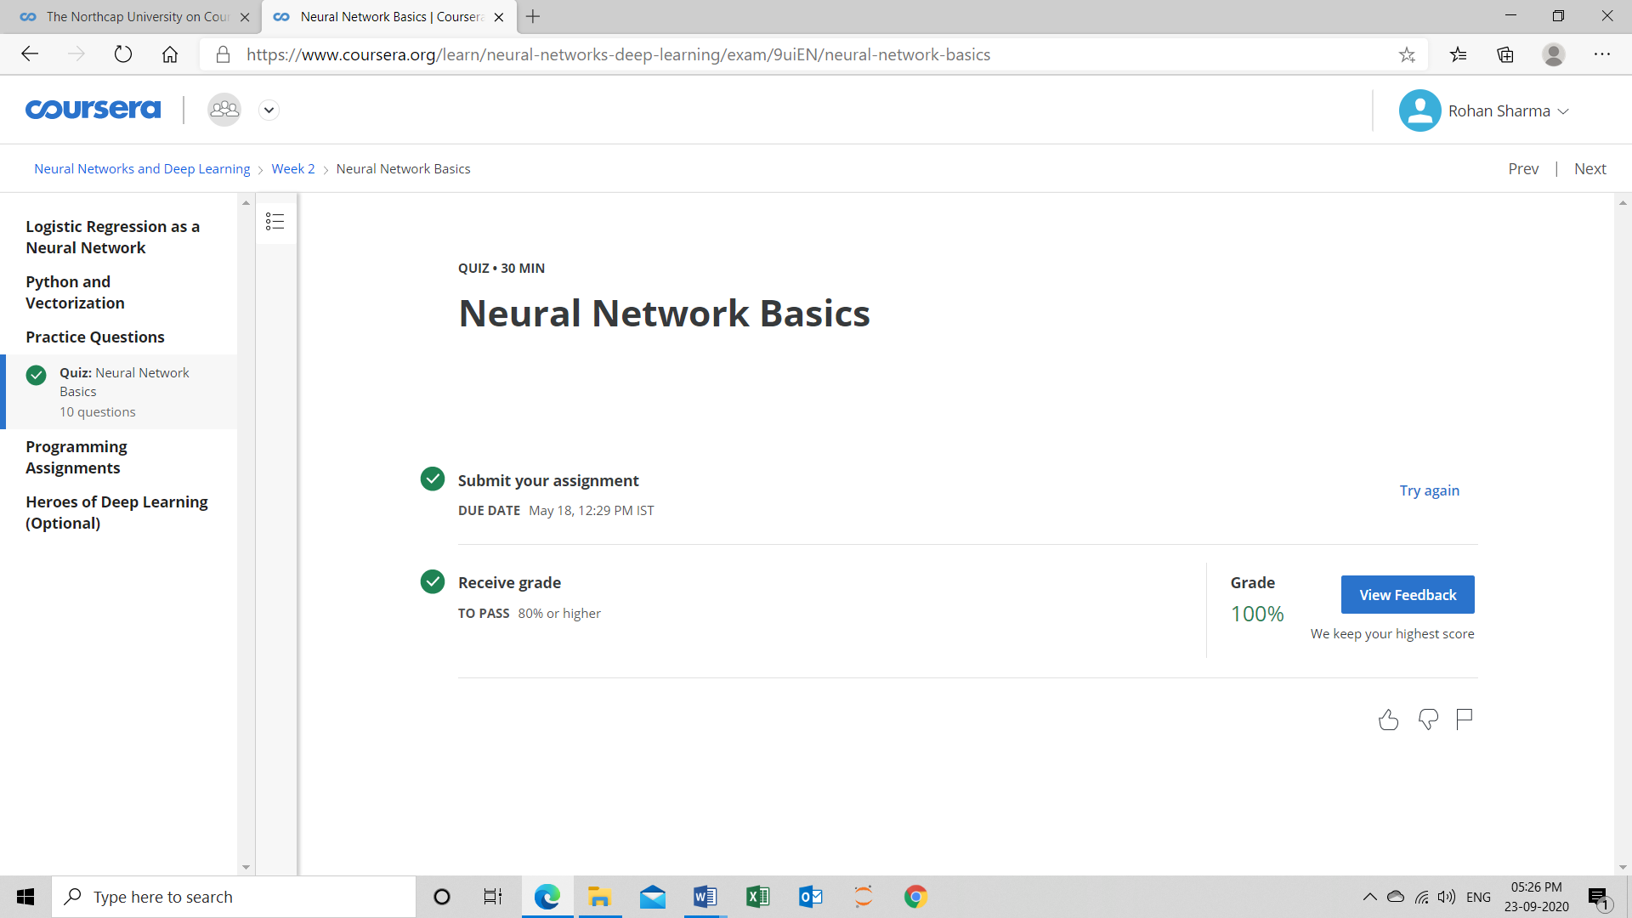

**Programming Assignment Outcome**

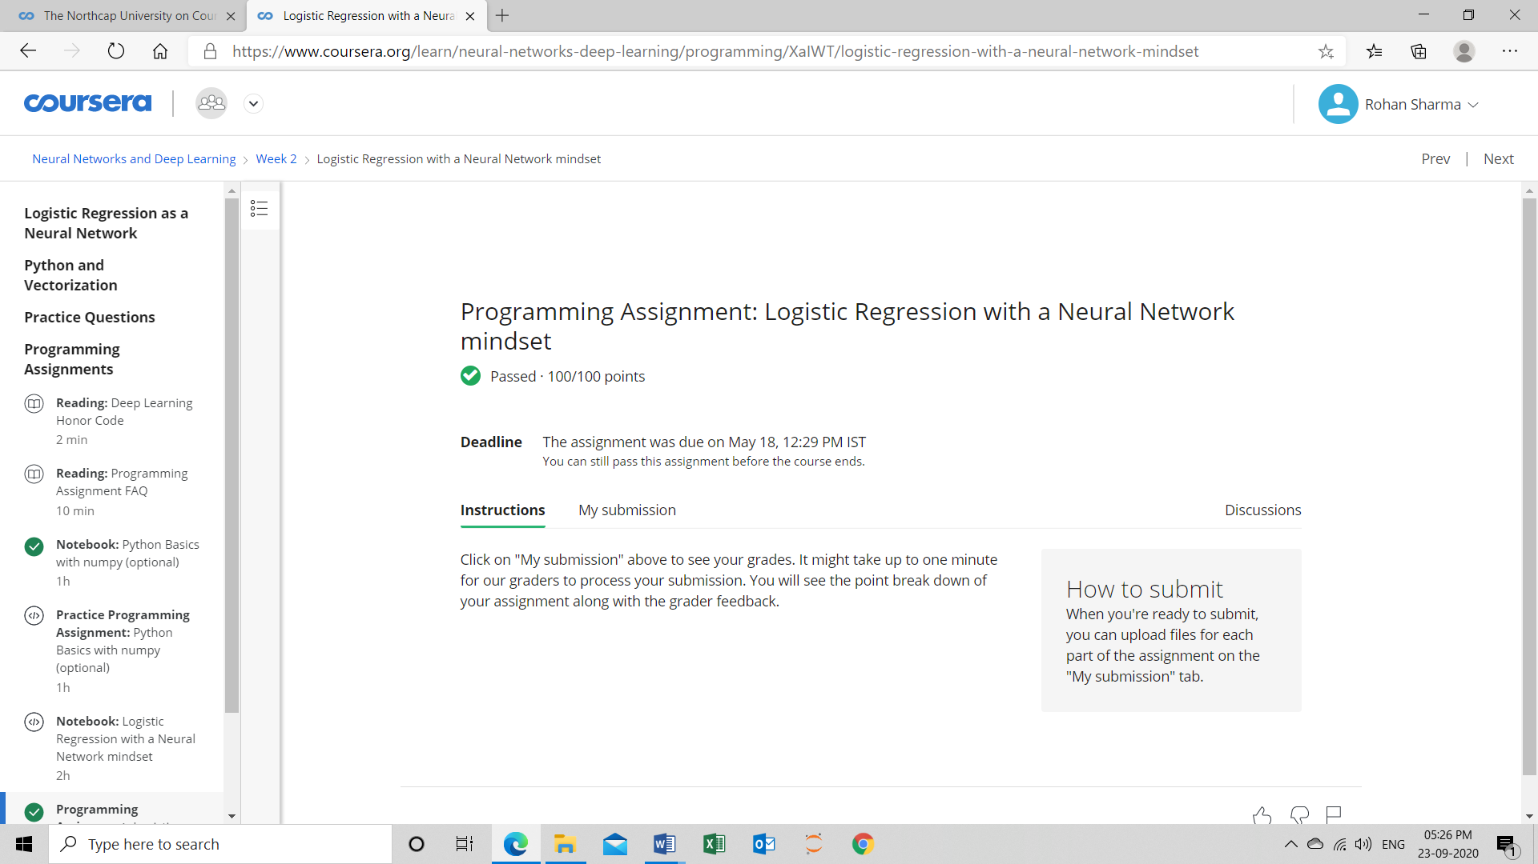

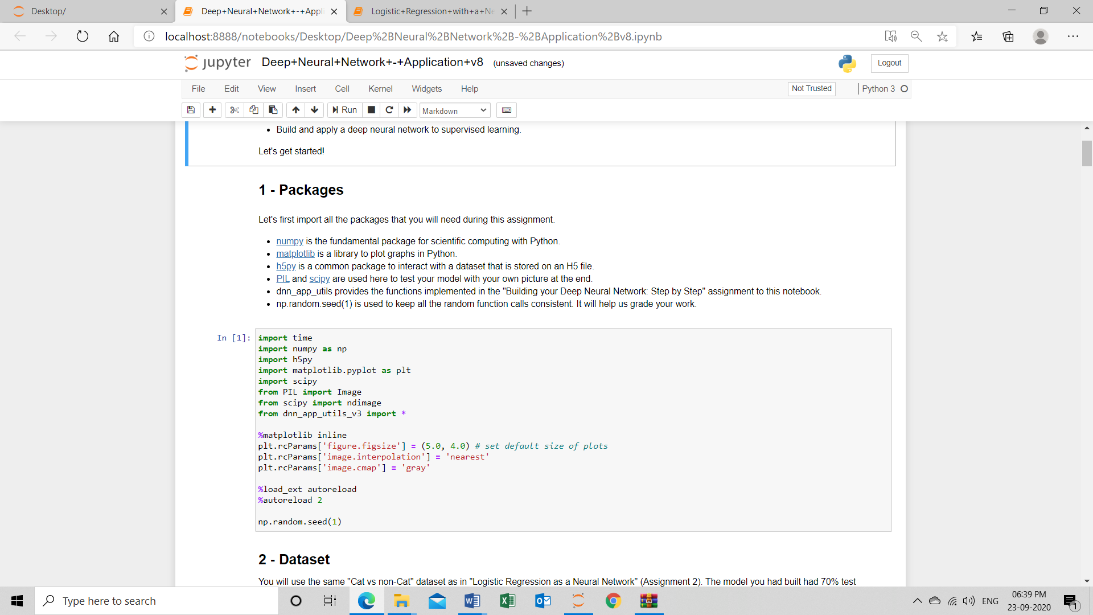

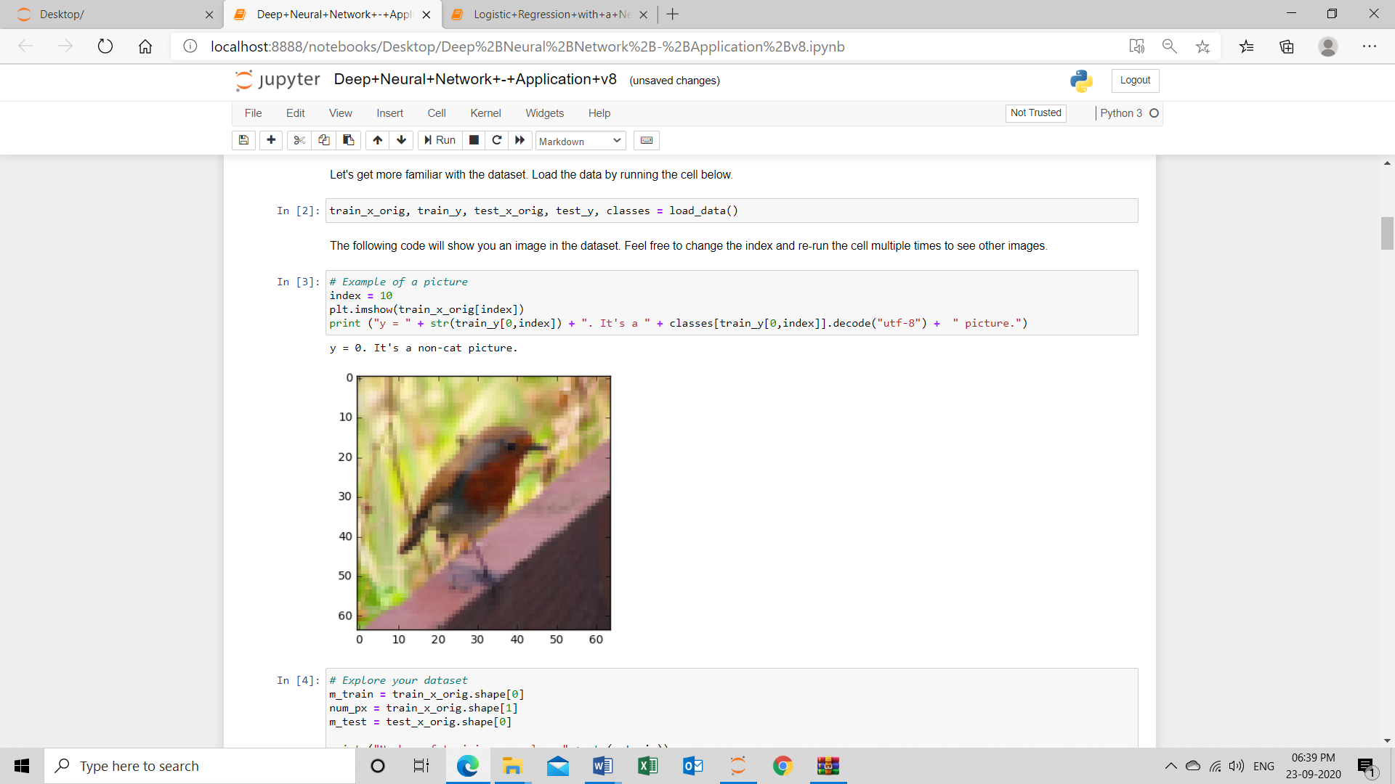

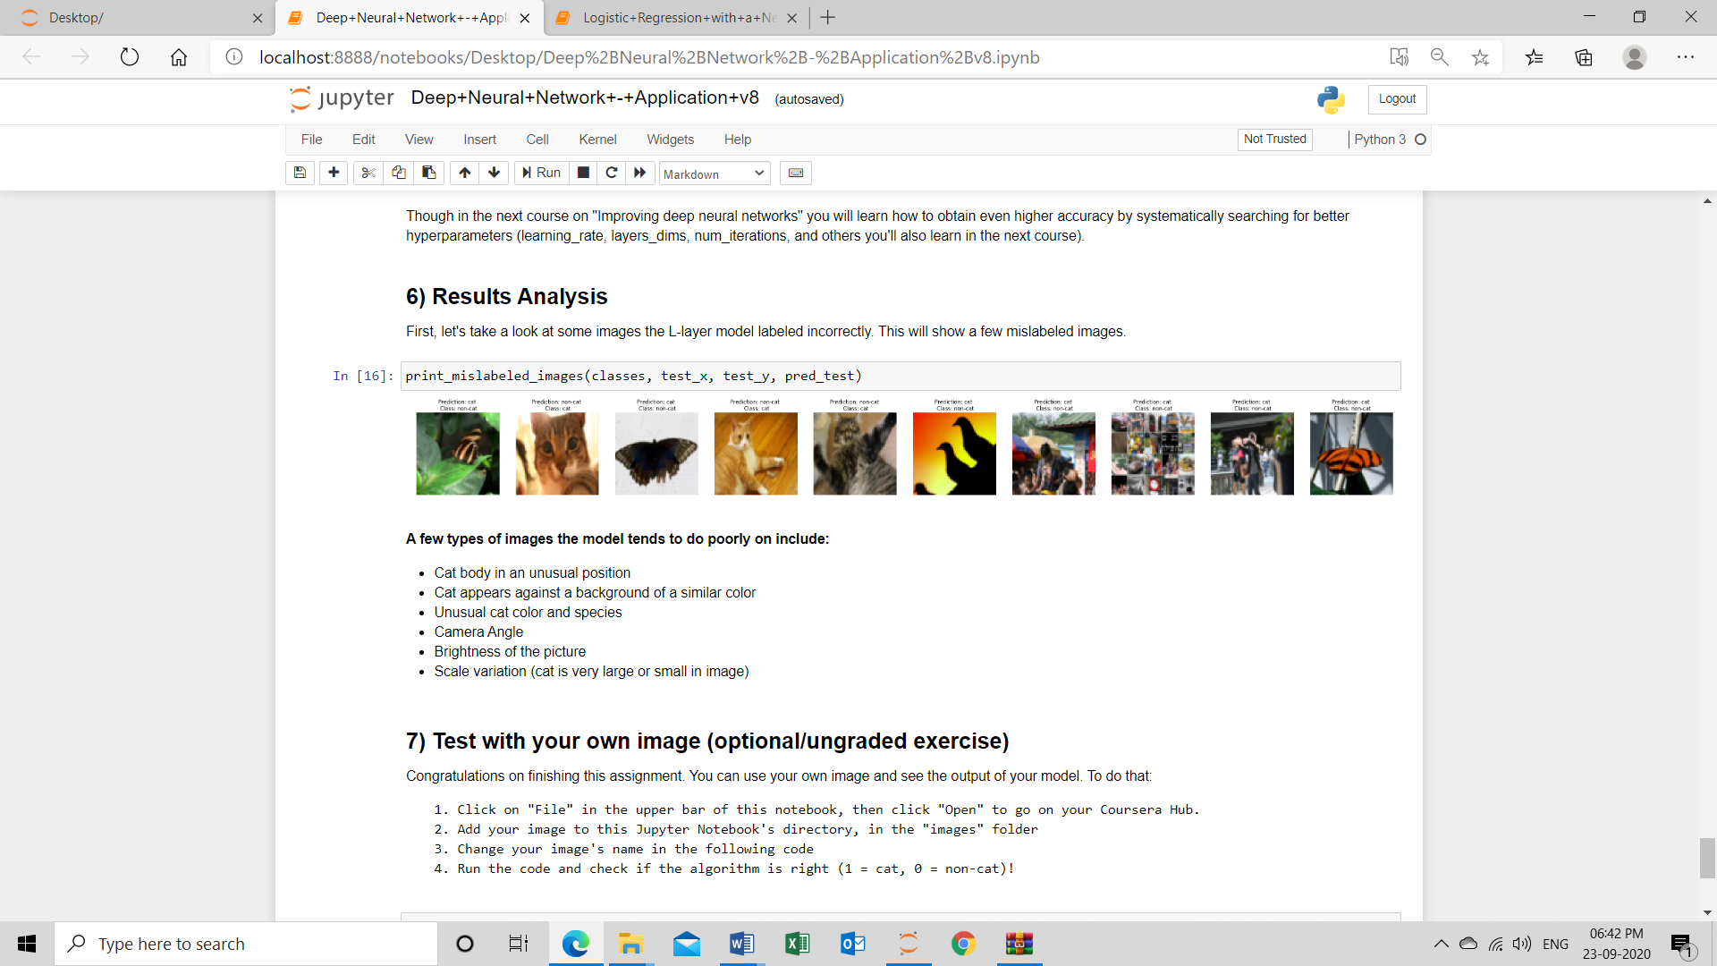

**Week 3 learning outcomes (Programming assignment)**

### **Key Concepts**

* Understand hidden units and hidden layers
* Be able to apply a variety of activation functions in a neural network.
* Build your first forward and backward propagation with a hidden layer
* Apply random initialization to your neural network
* Become fluent with Deep Learning notations and Neural Network Representations
* Build and train a neural network with one hidden layer.

**Quiz Outcome**

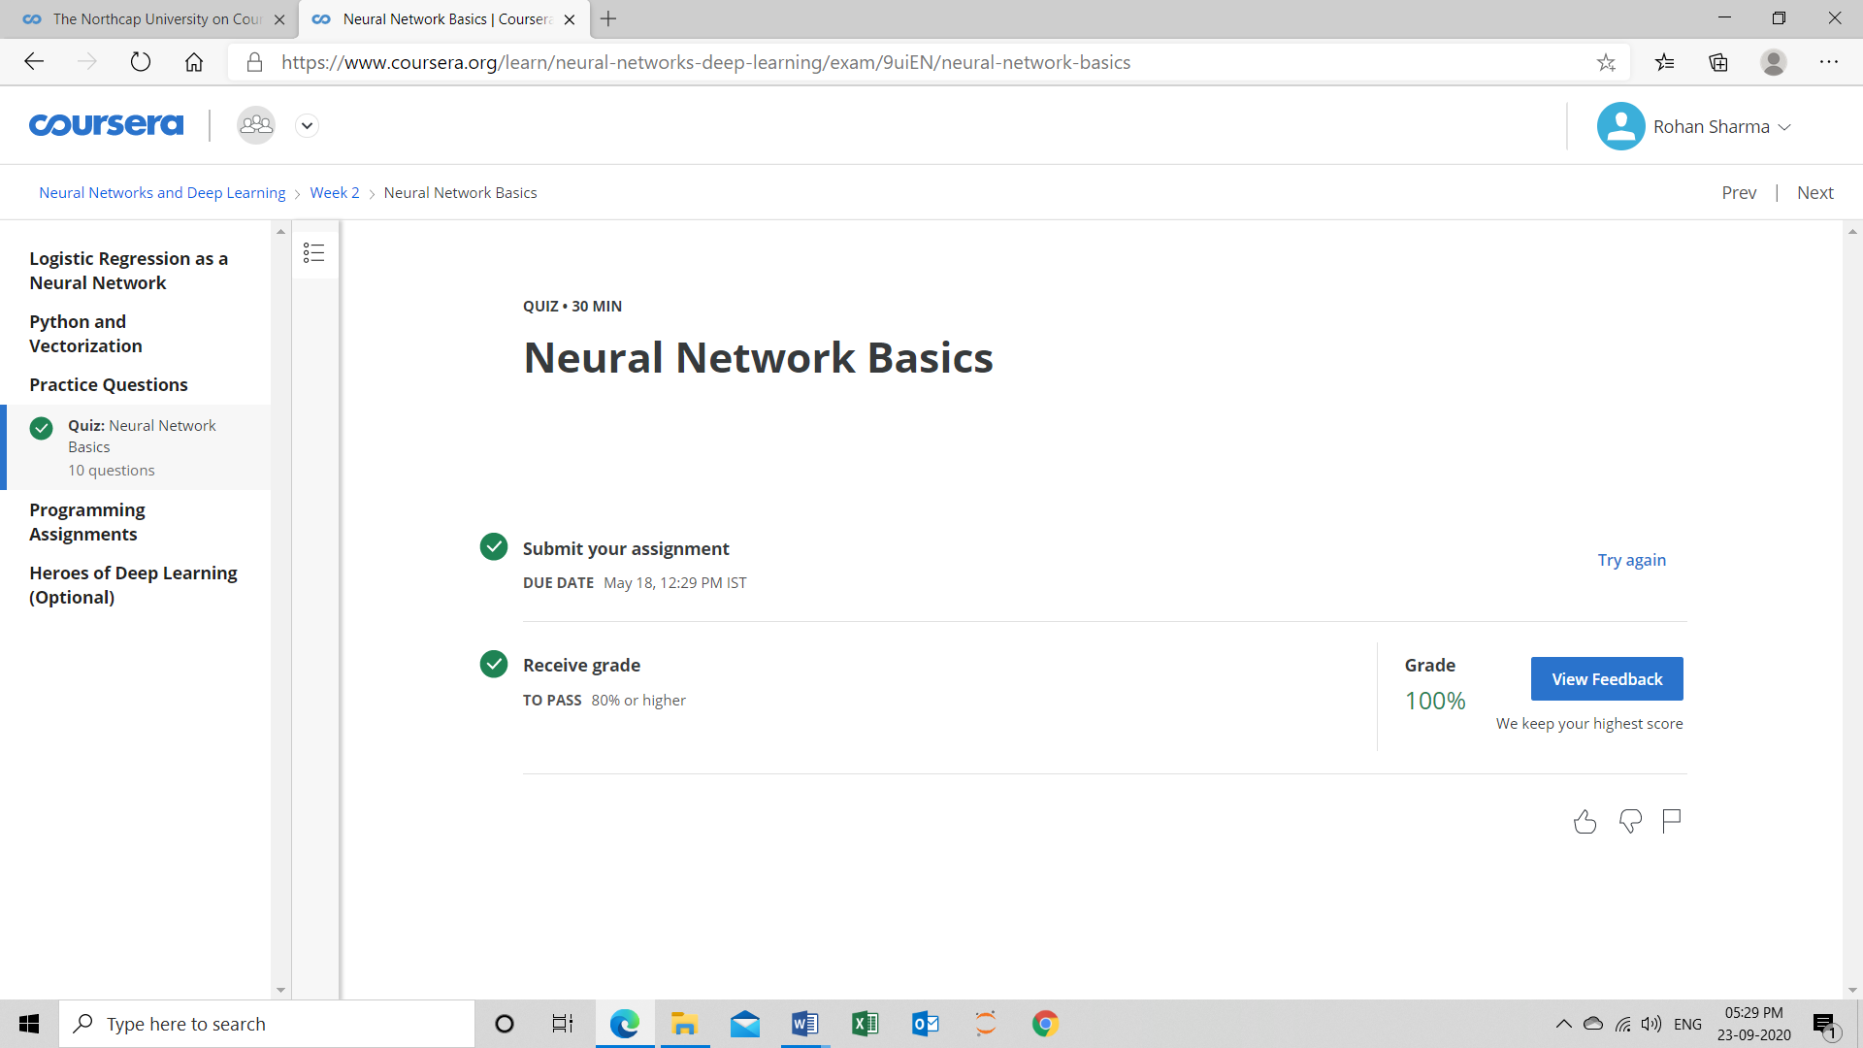

**Programming Assignment Outcome**

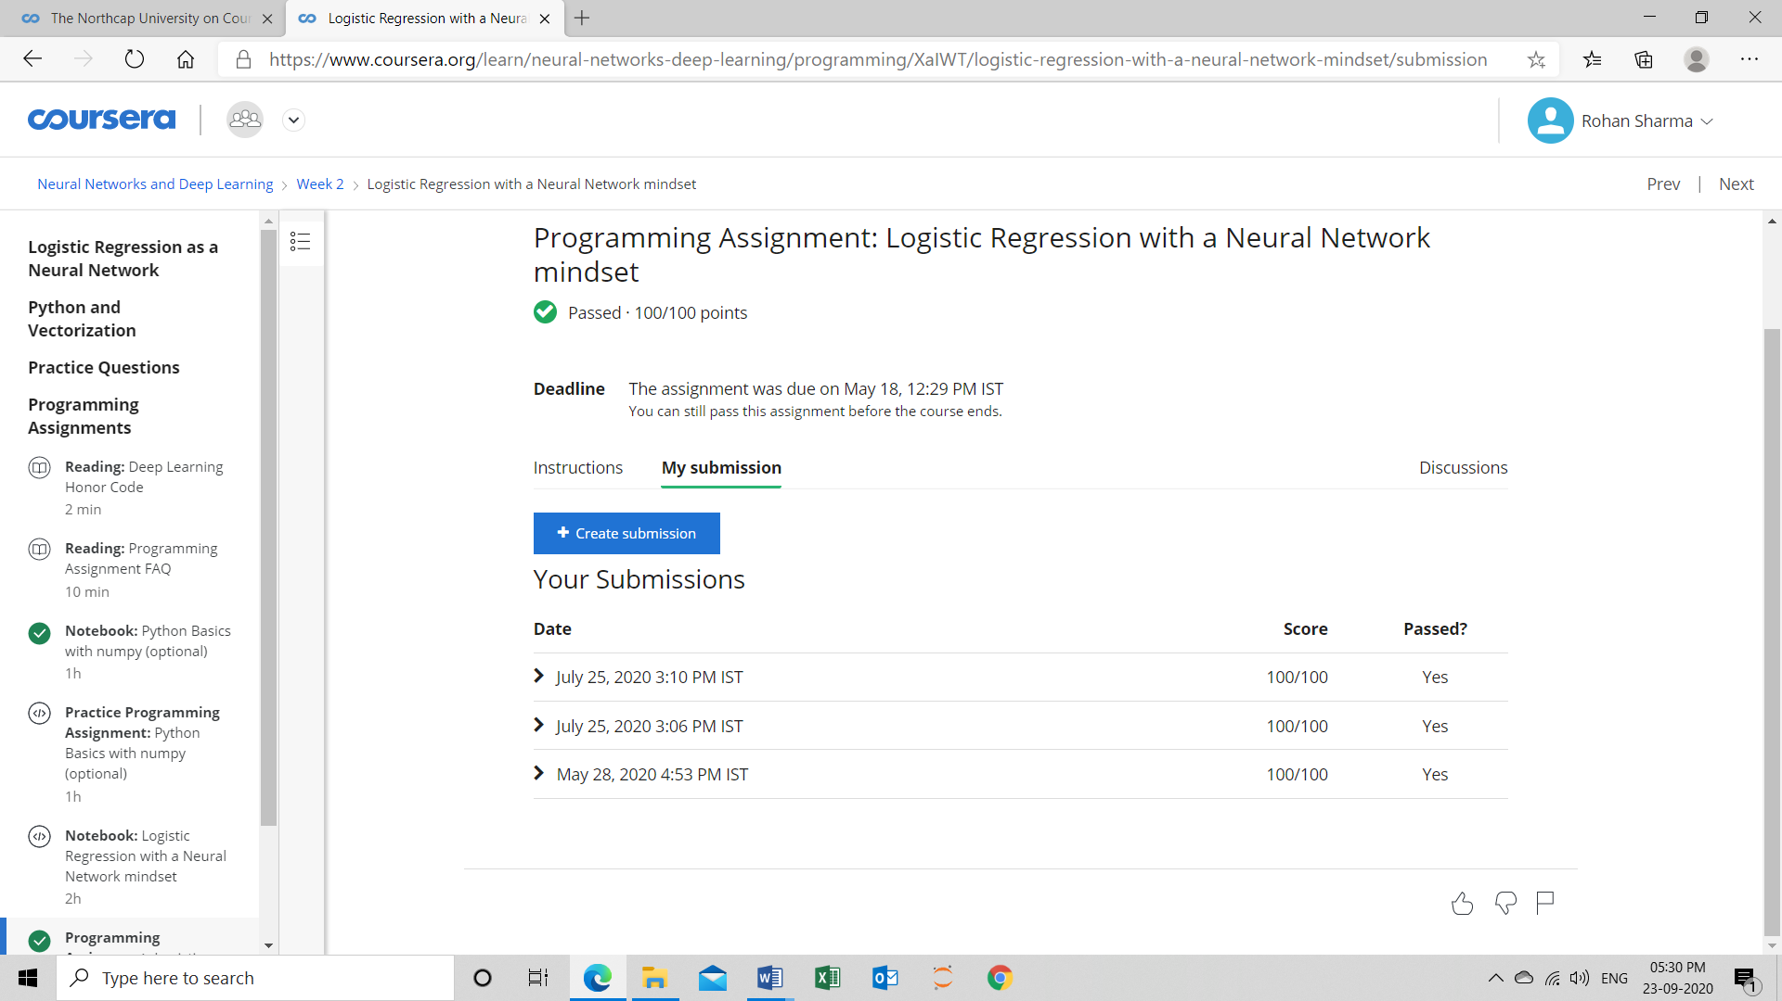

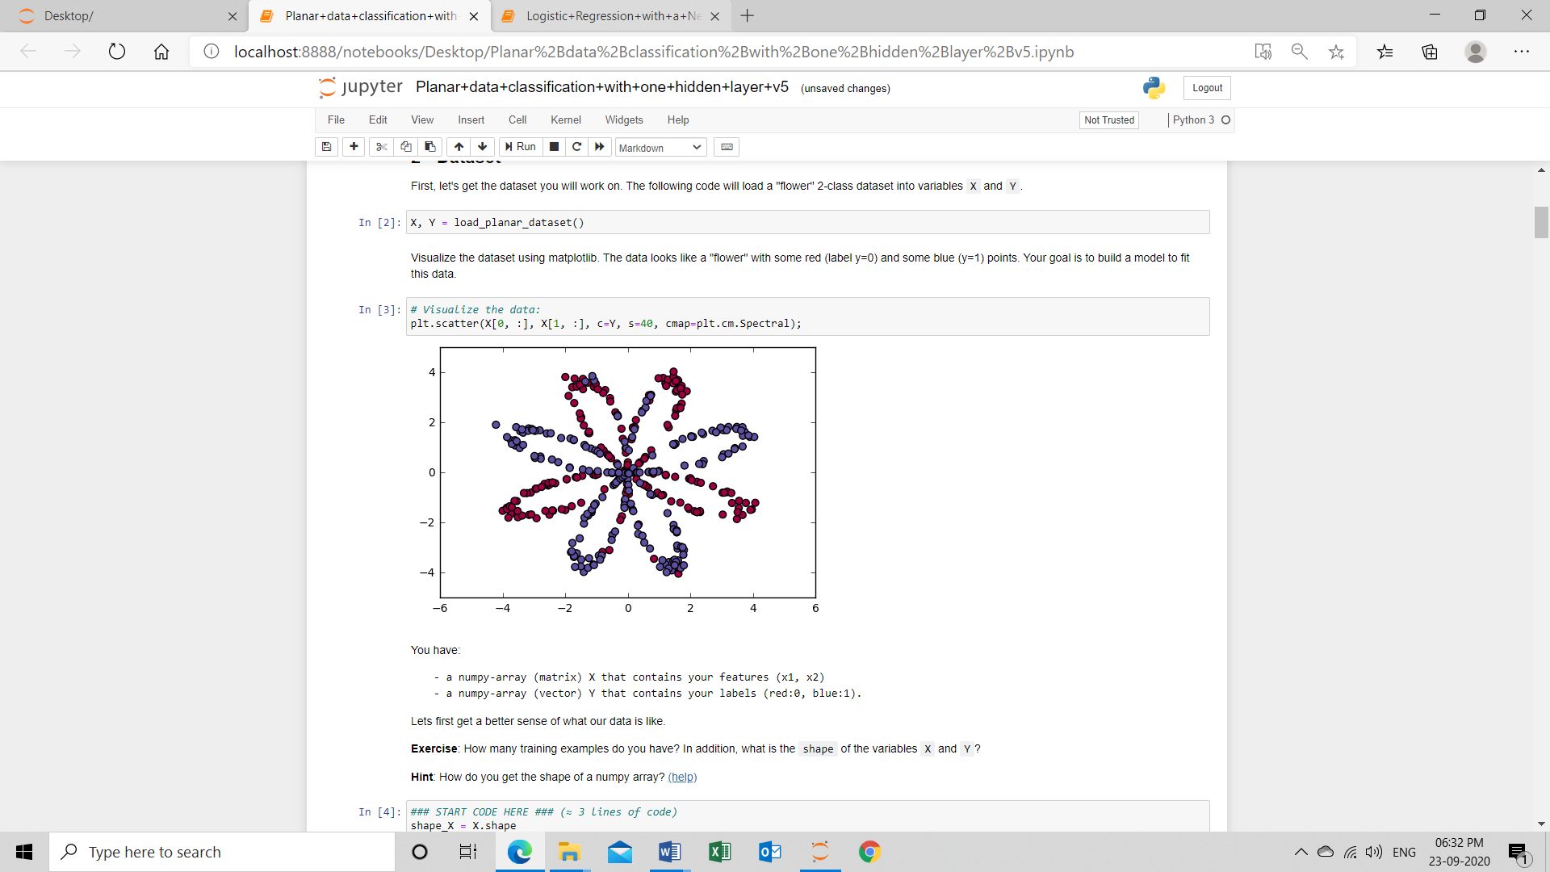

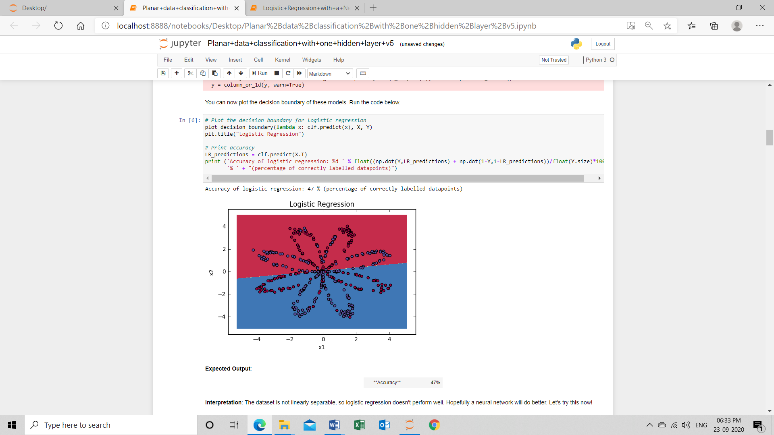

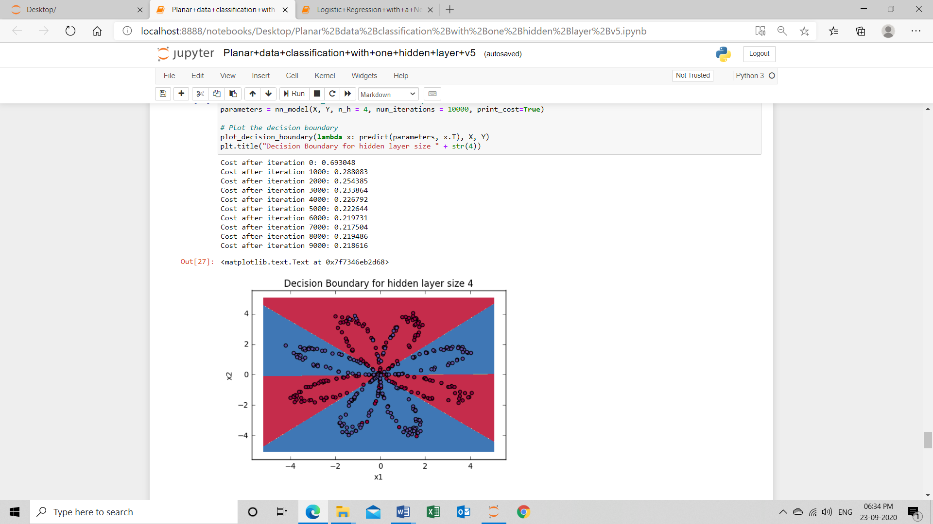

**Week 4 learning outcomes (Programming assignment)**

### **Key Concepts**

* See deep neural networks as successive blocks put one after each other
* Build and train a deep L-layer Neural Network
* Analyse matrix and vector dimensions to check neural network implementations.
* Understand how to use a cache to pass information from forward propagation to back propagation.
* Understand the role of hyperparameters in deep learning

**Deep Neural Network**

A deep neural network (DNN) is an artificial neural network (ANN) with multiple layers between the input and output layers. The DNN finds the correct mathematical manipulation to turn the input into the output, whether it be a linear relationship or a non-linear relationship.

**Quiz Outcome**

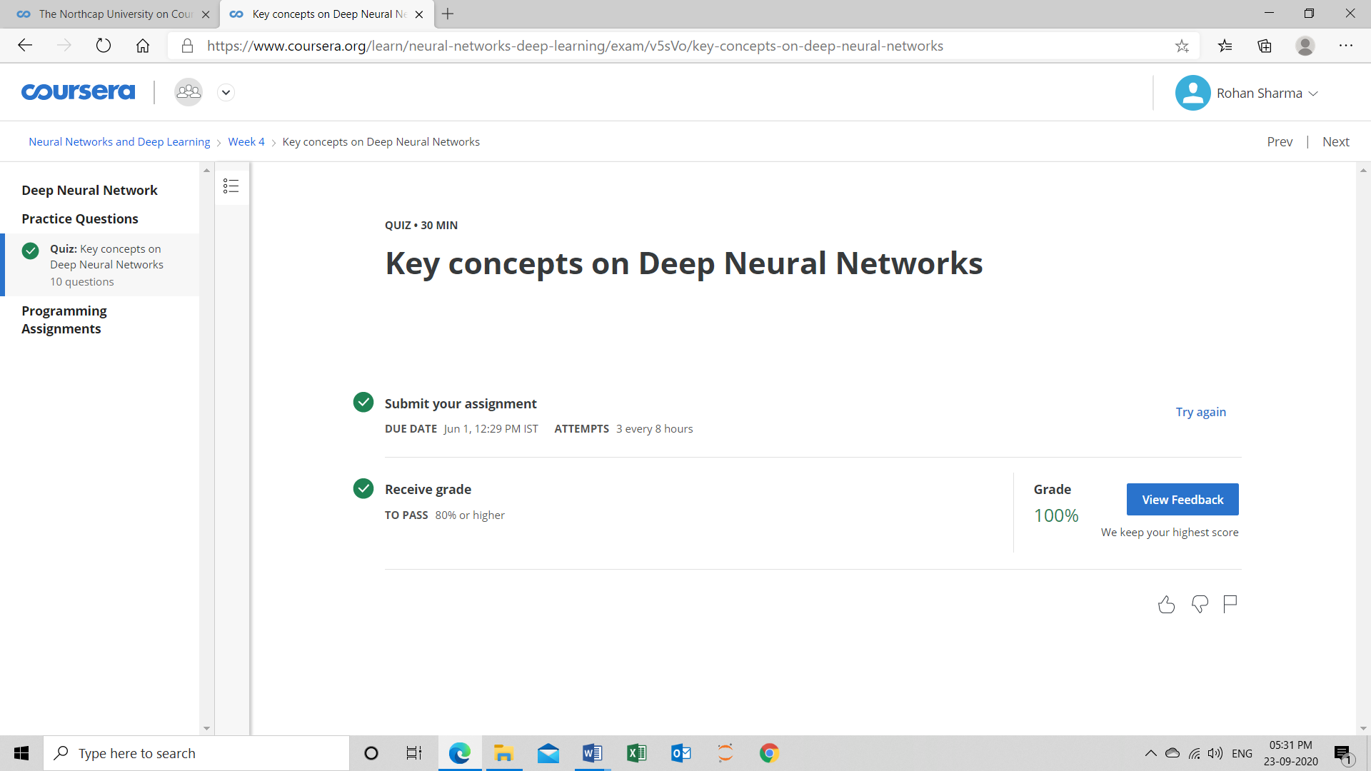

**Programming Assignment-1 Outcome**

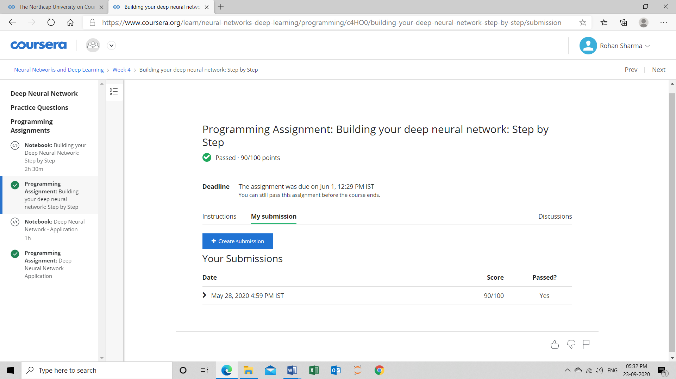

**Programming Assignment-2 Outcome**

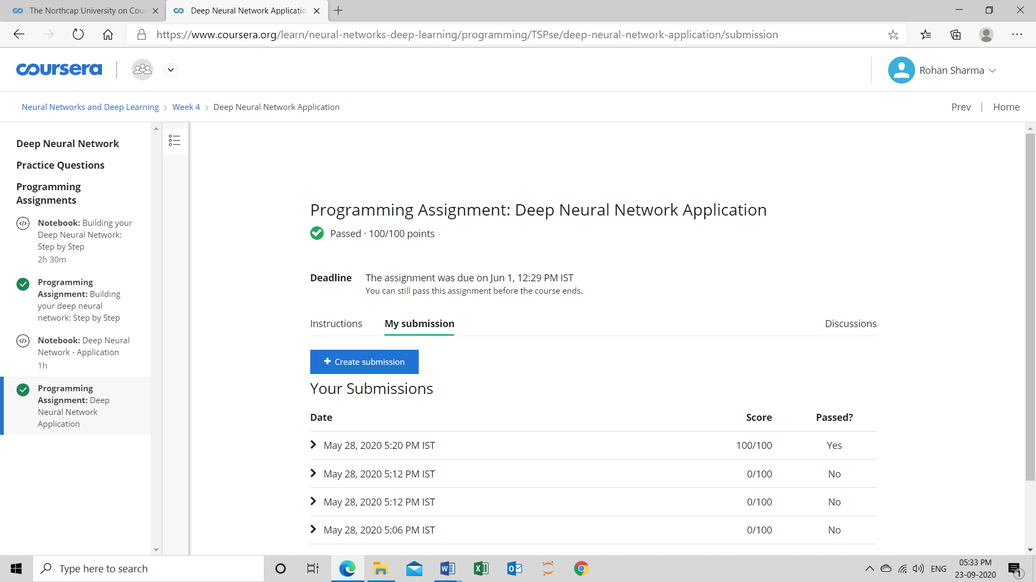

**Github :** <https://github.com/rohansharma03/Summer-Internship>

**Outcome on new Dataset**

## Planar data classification with a hidden layer

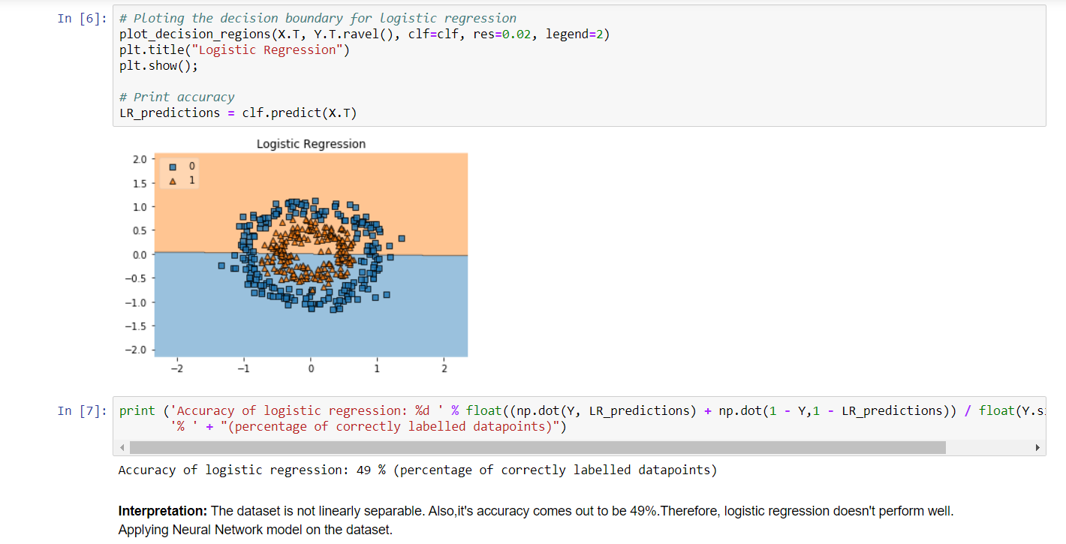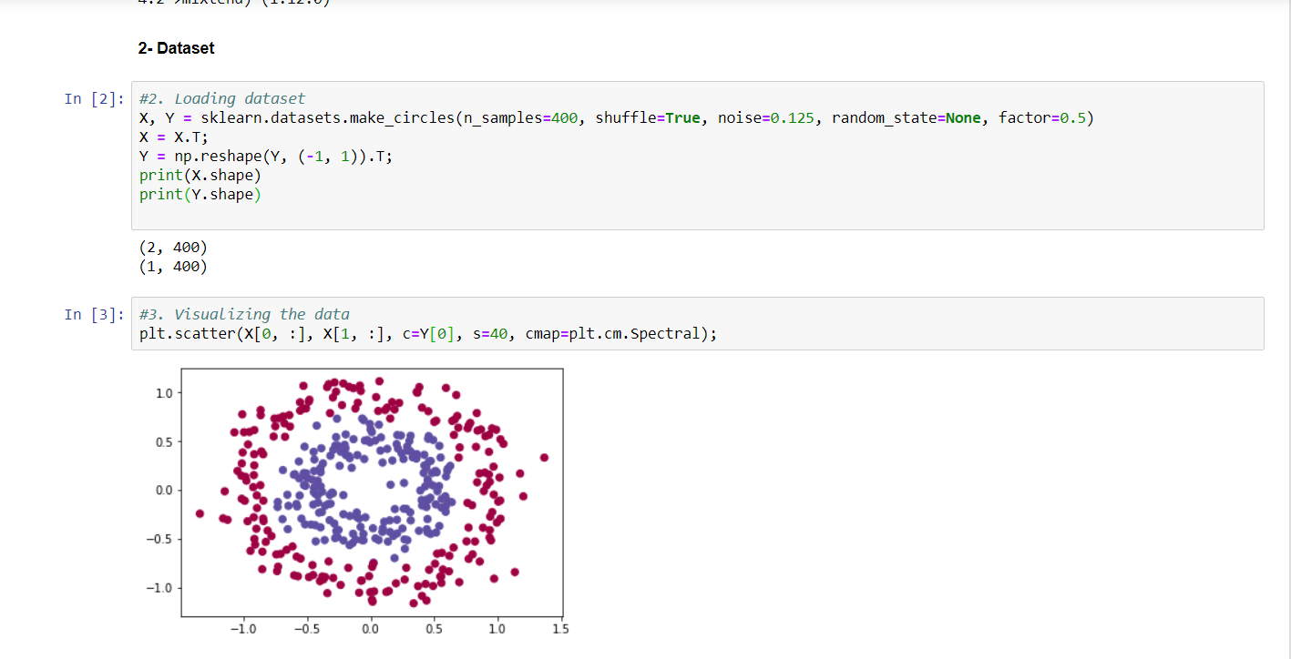

**Github:** <https://github.com/rohansharma03/Summer-Internship>

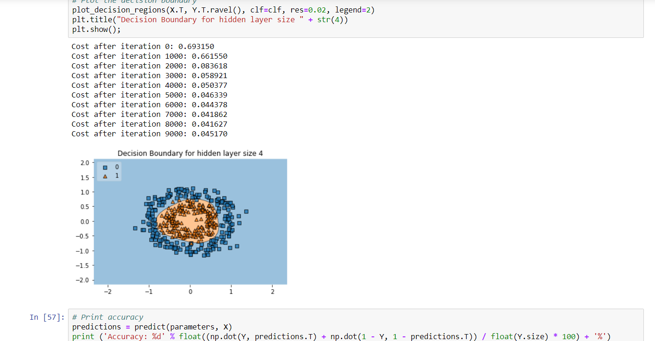

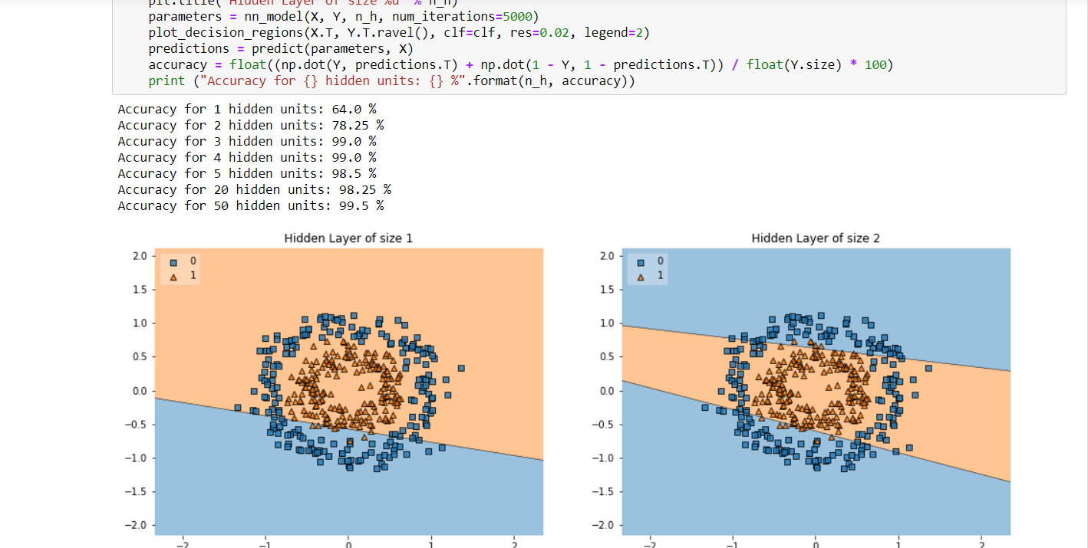

## Building your Deep Neural Network: Step by Step

**Github:** <https://github.com/rohansharma03/Summer-Internship>

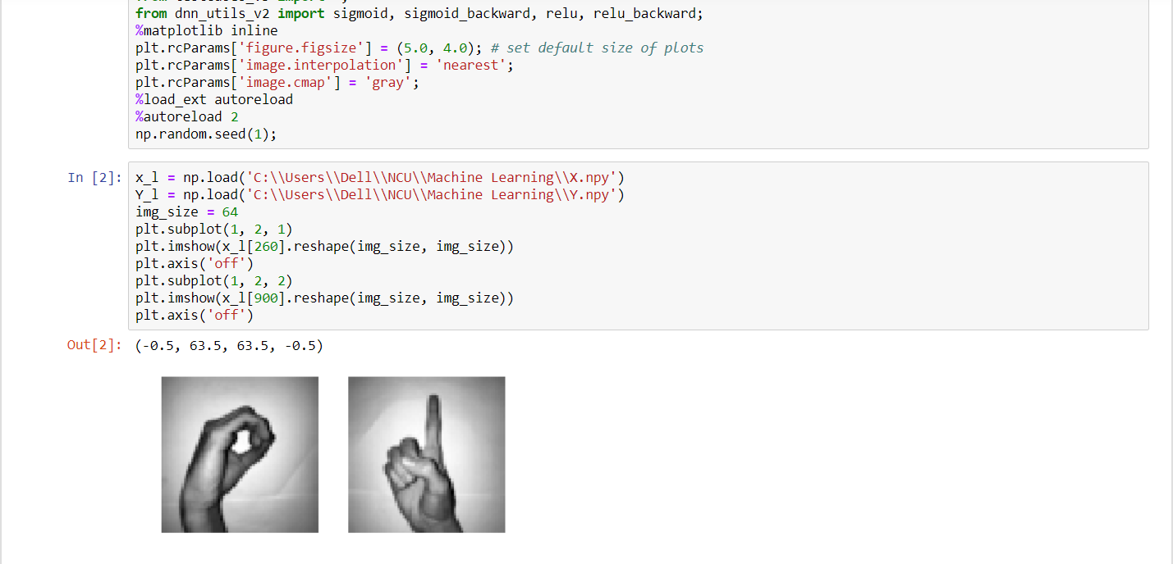

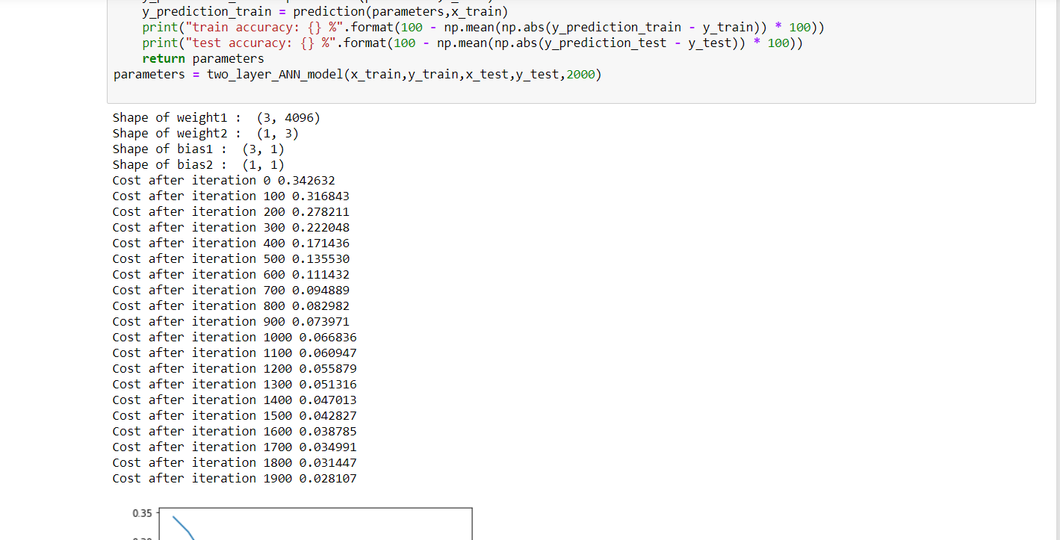

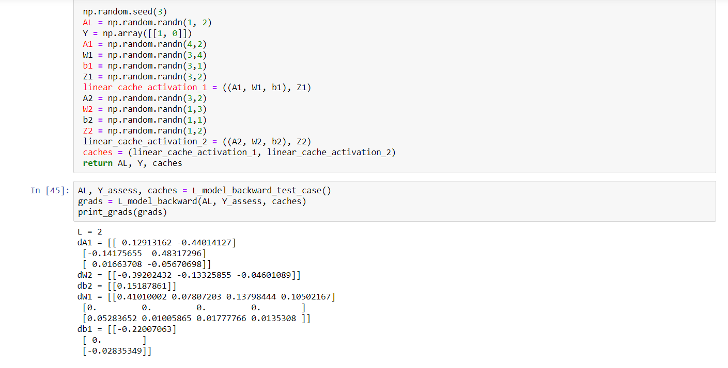

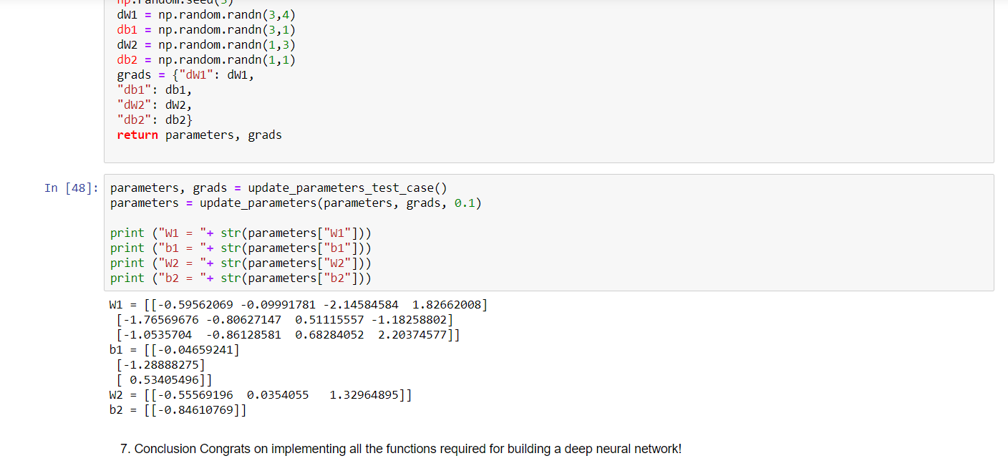

**Conclusion**

This specialization improved my skill-set in the field of Artificial Intelligence and made me capable of making more projects like this. By learning a wide range of techniques and applying some of them made an efficient use of my time and has now opened an entirely new world for me to explore.

Gaining the knowledge of deep learning and making this kind of project boosts my moral and motivate me to make complete end to end projects in future rather just making the prediction models

**REFERENCE**

* <https://www.coursera.org/learn/neural-networks-deep-learning/home/welcome>
* <https://towardsdatascience.com/introducing-deep-learning-and-neural-networks-deep-learning-for-rookies-1-bd68f9cf5883>
* <https://www.geeksforgeeks.org/introduction-deep-learning/>
* <https://pathmind.com/wiki/neural-network>

|  |  |  |  |
| --- | --- | --- | --- |
| Project Daily Task | | | |
| Date | | **Day** | **Work** |
| 1 May,2020 | | Friday | Started with Introduction and downloaded reading material. |
| 6 May,2020 | | Wednesday | Quiz for week 1 |
| 09 May,2020 | | Saturday | Quiz for week 2 |
| 14 May 2020 | | Thursday | Program file for week 2 |
| 16 May 2020 | | Saturday | Quiz for week 3 |
| 19 May 2020 | | Tuesday | Program file 1 completed for week 3 |
| 21 May 2020 | | Thursday | Program file 2 completed for week 3 |
| 22 May 2020 | | Friday | Week 4 quiz |
| 25 May 2020 | | Monday | Program file completed for week 4 |
| 25 May,2020 | | Monday | Certificate issued |
| 15 June 2020 | Monday | | Started with making report | |
| 2 July 2020 | | Thursday | Finished with report making |
| 15 August 2020 | | Saturday | Made ppt for evaluation |
| 25 sept 2020 | | Friday | Final evaluation day |
|  | |  |  |